Tips & Tricks

1. We can use bitwise operators to find the element in the array which is not repeated more than once.
2. We can initialize a variable by int a(23);
3. when we do right shift by 1 we are dividing the number by 2. Eg. 12>>1 = 6, 12>>2=3, 12<<2=48. This will be faster than 12/2.
4. If we want to check the last bit of a binary number we and with 1 if the result is one the last is 1 else 0. We can also use this to find odd/even.
5. A number is even if its last bit is 0. Hence any number whose and with 1 is 0 is even.
6. 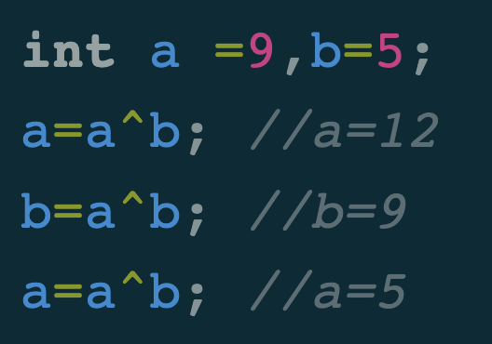To swap two number we can use bitwise operators without using third variable.
7. To find number of digits in a number we do log10N +1 🡪 log10(N).

**int**(log10(123456)+1)

1. To take log2 we use log2(N).
2. N & (N-1) sets 0 to the least significant bit. When run till i.e.

1001🡪1000, 1100 🡪 1000

1. **Convert binary code directly into an integer in C++**

**auto number = 0b011;**

1. **Swap two numbers**

a ^= b;

    b ^= a;

    a ^= b;